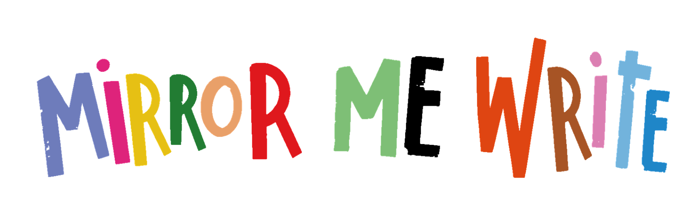

Early Years and Primary School
*Our Key Stage categories are there as a basic guide to teachers.
Some book titles feature in multiple bands, to consider the different abilities of readers.
For any guidance or advice please drop us an email at
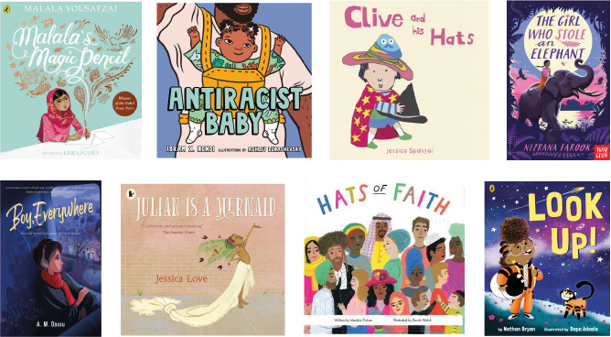
hello@mirrormewrite.com

Early Years Foundation Stage (EYFS)
Title | Price | Quantity
Clive and his Art | £4.99
Clive and his Hats | £4.99
Counting on Katherine | £10.99
Dance (Amazing Me!) | £4.99
Getting Ready: BSL (Sign About) | £4.99
Hats of Faith | £8.99
Just Like You | £5.99
My First Signs | £5.99
Rosa Loves Dinosaurs | £4.99
Rosa Plays Ball | £4.99
The Drum | £9.99

EYFS and Key Stage 1
Title | Price | Quantity
A Story About Afiya | £11.99
Alive Again | £9.99
An ABC of Equality (Board Book) | £9.99
Antiracist Baby | £6.99
Buster Finds His Beat | £8.99
DARE | £6.99
Grandfather Gandhi | £12.99
I Am Brown | £11.99
Julian is a Mermaid | £7.99
Kaya's Heart Song | £7.99
Maisie's Scrapbook | £7.99
Mira's Curly Hair | £7.99
Mommy's Khimar | £12.99
My Hair | £6.99
Nimesh the Adventurer | £7.99
Pattu's Dosa | £7.99
Phoenix Song | £6.99
She's My Twin Sister | £6.99
Sleep Well, Siba and Saba | £7.99
Splash, Anna Hibiscus | £7.99
That's My New Friend: The Twinadventures | £10.99
There's Room for Everyone | £7.99
We Are Muslim | £6.99
Welcome to Our World: A Celebration of Children Everywhere! | £12.99
Who Do I See in the Mirror? | £8.99

Key Stage 1
Title | Price | Quantity
Azizi and The Little Blue Bird | £11.99
Bijan and Manije | £12.99
Bilal Cooks Daal | £10.99
Cinderella of the Nile | £7.99
Clean Up! | £6.99
Desmond And The Very Mean Word | £12.99
Dolly May and the Magical Enchanted Garden | £9.99
Dragon Dancer | £6.99
Errol's Garden | £6.99
Eve's New Brother | £6.99
Fauja Singh Keeps Going | £13.99
Felix After The Rain | £7.99
Football Star | £7.99
Grobblechops (Tales by Rumi) | £12.99
Hair Love | £6.99
How To Be Extraordinary | £6.99
If All The World Were... | £12.99
Leila in Saffron | £12.99
Look up! | £6.99
Malala's Magic Pencil | £7.99
Ossiri and the Bala Mengro | £6.99
Parker Looks Up | £12.99
Polonius the Pit Pony | £6.99
Quill Soup | £12.99
Ramadan Moon | £6.99
Shine | £7.99
Sing to the Moon | £6.99
Sulwe | £12.99
The Ammuchi Puchi | £6.99
The Lost Homework | £6.99
The Mysterious Dinosaurs of Crystal Palace | £8.99
The No. 1 Car Spotter | £5.99
The Parrot and the Merchant (Tales by Rumi) | £7.99
The Phoenix of Persia | £12.99
The Proudest Blue | £7.99
The Wooden Camel | £6.99
Tomorrow | £7.99
Too Small Tola | £5.99
Yokki and the Parno Gry | £6.99

Key Stage 2
Title | Price | Quantity
A Caribbean Dozen | £5.99
A Dollop Of Ghee And A Pot of Wisdom | £6.99
A Kind of Spark | £6.99
A Pocketful of Stars | £6.99
Amari and the Night Brothers | £12.99
Amina's Voice | £6.99
Asha and the Spirit Bird | £6.99
Becoming Muhammad Ali | £8.99
Boy, Everywhere | £7.99
Children of the Benin Kingdom | £6.99
Front Desk | £6.99
Ghost Boys | £6.99
Little Badman and the Invasion of the Killer Aunties | £6.99
Noor-un-Nissa Inayat Khan - My Story | £6.99
Peace and Me | £12.99
Planet Omar 1: Accidental Trouble Magnet | £6.99
Planet Omar 2: Unexpected Super Spy | £6.99
Planet Omar 3: Incredible Rescue Mission | £6.99
Step Into Your Power | £14.99
Tamarind and the Star of Ishta | £6.99
The A-Z of Wonder Women | £7.99
The Boy at the Back of the Class | £6.99
The Boy Who Met a Whale | £7.99
The Crossover | £7.99
The Girl Who Stole An Elephant | £6.99
The Night Bus Hero | £6.99
The Star Outside my Window | £6.99
The Undefeated | £7.99
The Whistling Monster: Stories from Around the World | £5.99
Three Keys | £6.99
Under the Moon and Over the Sea | £7.99
When Life Gives You Mangoes | £7.99
When Secrets Set Sail | £7.99
Where the River Runs Gold | £6.99
Windrush Child | £6.99
You Must Be Layla | £6.99

EYFS, Key Stage 1 and Key Stage 2
Title | Price | Quantity
When I Coloured in the World | £7.99

Please return completed form, digitally or scanned, to hello@mirrormewrite.com
